LESSON 2 WORKSHEET

1. 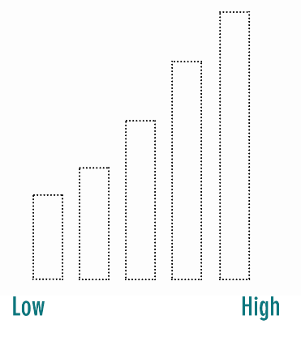*When I feel very sleepy or sick, I have ___________ energy.* Color in the bars to show how much energy you have when you feel very sleepy or sick:
2. How does your body move and act?

___________________________________________________________

___________________________________________________________

1. How does your mind feel?

* Slow
* Smart
* Foggy
* Hard to concentrate
* Thinking very fast
* Confused

1. What does your face look like? Circle the sleepy Codi:

|  |  |  |
| --- | --- | --- |
|  |  |  |

1. What might be happening around you to make you feel this way?

___________________________________________________________

1. What is one thing you could do to try change from feeling sleepy during the day?

___________________________________________________________

LESSON 3 WORKSHEET



1. *When I feel bored or sad I have ___________ energy.* Color in the bars to show how much energy you have when you feel bored or sad:
2. How does your body move and act?

__________________________________________________________

1. How does your mind feel?

* Slow
* Smart
* Foggy
* Hard to concentrate
* Thinking very fast
* Confused

1. What does your face look like? Circle the sad Codi:

|  |  |  |
| --- | --- | --- |
|  |  |  |

1. What might be happening around you to make you feel this way?

___________________________________________________________

1. What is one thing you could do to try change from feeling low energy during the day?

___________________________________________________________

LESSON 4 WORKSHEET

1. *When I feel very worried or fed up, I have ___________ energy.* Color in the bars to show how much energy you have when you feel tense:
2. How does your body move and act?

___________________________________________________________

1. How does your mind feel?

* Slow
* Smart
* Jittery
* Hard to concentrate
* Thinking very fast
* Confused

1. What does your face look like? Circle the worried Codi:

|  |  |  |
| --- | --- | --- |
|  |  |  |

1. What might be happening around you to make you feel this way?

___________________________________________________________

___________________________________________________________

1. What is one thing you could do to try change from feeling tense during the day?

___________________________________________________________

LESSON 5 WORKSHEET

1. *When I feel very angry I have ___________ energy.* Color in the bars to show how much energy you have when you feel very angry and intense:
2. How does your body move and act? ___________________________________________________________
3. How does your mind feel?

* Agitated
* Smart
* Foggy
* Hard to concentrate
* Thinking very fast
* Confused

1. What does your face look like? Circle the angry Codi:

|  |  |  |
| --- | --- | --- |
|  |  |  |

1. What might be happening around you to make you feel this way?

___________________________________________________________

1. What is one thing you could do to try change from feeling intense during the day?

___________________________________________________________

1. Name some quiet places you could go for a little break to help you feel more calm and happy:

___________________________________________________________________

LESSON 6 WORKSHEET

1. *When I feel calm, I have ___________ energy.* Color in the bars to show how much energy you have when you feel calm and happy:
2. How does your body move and act?

___________________________________________________________

1. How does your mind feel?

* Slow
* Good
* Jittery
* Ready to concentrate
* Thinking very fast
* Relaxed

1. What does your face look like? Circle the happy Codi:

|  |  |  |
| --- | --- | --- |
|  |  |  |

1. What are some things that make you happy?

___________________________________________________________

___________________________________________________________

1. What is one thing you do that makes you feel calm?

__________________________________________________________

Name ____________________